Homework 7 — SQL Work
  - Part 3: SQL Server Practice | Statements and verified sample results
Student: Darius Sweatman | Course: C# Programming II (CIST2342)

How to use this document
The SQL below is designed for Microsoft SQL Server Management Studio (SSMS) or Azure Data Studio. The sample-result panels show real local tests using SQLite with equivalent tables and SQL functions. They are NOT SSMS screenshots. For full compliance with the assignment, run each query in SSMS and replace these example panels with your own screenshots showing the SQL editor above the Results grid.
Run the setup script first, then run Queries 1–5 in order. The price update in Query 4 should only run once unless you reset the tables, and Query 5 removes BookID 105.

1 | Create the tables
CREATE TABLE dbo.Authors (
AuthorID INT PRIMARY KEY,
FirstName NVARCHAR(50),
LastName NVARCHAR(50)
);
CREATE TABLE dbo.Publishers (
PublisherID INT PRIMARY KEY,
PublisherName NVARCHAR(100)
);
CREATE TABLE dbo.Books (
BookID INT PRIMARY KEY,
Title NVARCHAR(100),
Price DECIMAL(8,2),
PublisherID INT NOT NULL,
AuthorID INT NOT NULL,
CONSTRAINT FK_Books_Publishers FOREIGN KEY (PublisherID)
REFERENCES dbo.Publishers(PublisherID),
CONSTRAINT FK_Books_Authors FOREIGN KEY (AuthorID)
REFERENCES dbo.Authors(AuthorID)
);

The separate .sql script contains drop-if-exists statements so the tables can be created again when needed.

2 | Insert sample data
INSERT INTO dbo.Authors VALUES
(1, N'Jordan', N'Lee'),
(2, N'Casey', N'Smith'),
(3, N'Morgan', N'Davis');
INSERT INTO dbo.Publishers VALUES
(1, N'Murach'),
(2, N'Northstar Books');
INSERT INTO dbo.Books VALUES
(101, N'C# Fundamentals', 49.95, 1, 1),
(102, N'SQL Server Essentials', 59.95, 1, 2),
(103, N'Database Design Made Simple', 44.50, 2, 1),
(104, N'Practical ADO.NET', 54.00, 1, 2),
(105, N'Software Testing Basics', 39.99, 2, 3);

The Authors and Publishers rows are inserted before Books to satisfy the foreign key constraints.

3 | Run and capture queries

Query 1 | Display books with authors
SELECT b.BookID, b.Title,
CONCAT(a.FirstName, ' ', a.LastName) AS AuthorName
FROM dbo.Books AS b
INNER JOIN dbo.Authors AS a ON b.AuthorID = a.AuthorID
ORDER BY b.BookID;

Local verification panel (not an SSMS screenshot):
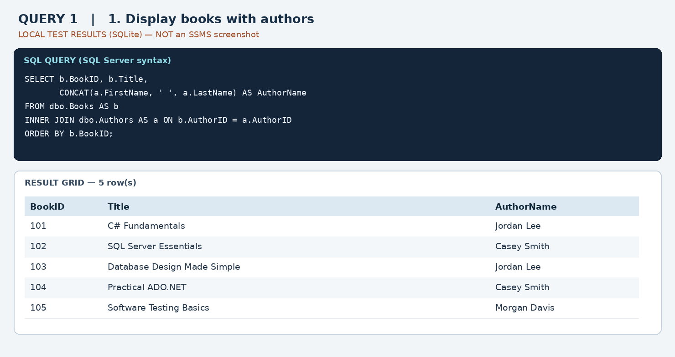

Query 2 | Books by Murach
SELECT b.BookID, b.Title, p.PublisherName
FROM dbo.Books AS b
INNER JOIN dbo.Publishers AS p ON b.PublisherID = p.PublisherID
WHERE p.PublisherName = N'Murach'
ORDER BY b.BookID;

Local verification panel (not an SSMS screenshot):
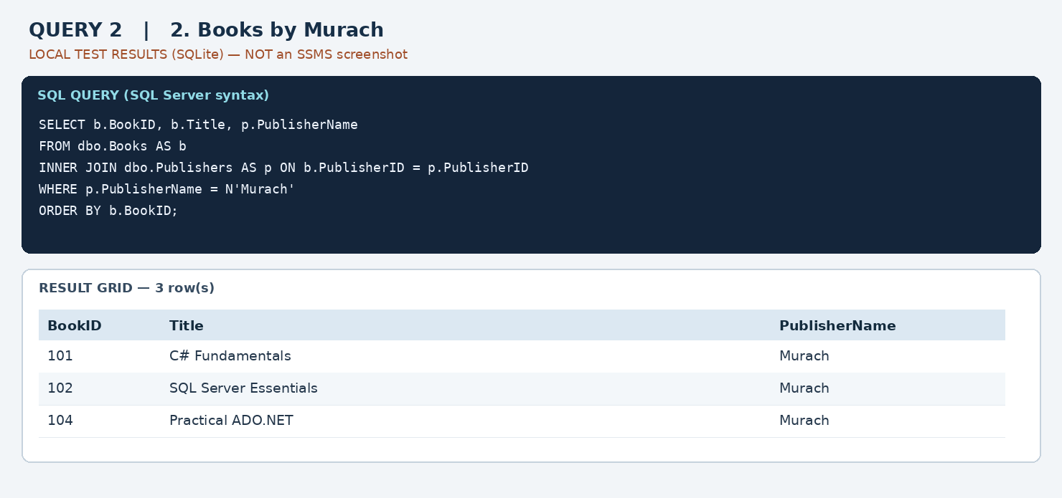

Query 3 | Authors with more than one book
SELECT a.AuthorID,
CONCAT(a.FirstName, ' ', a.LastName) AS AuthorName,
COUNT(*) AS BooksWritten
FROM dbo.Authors AS a
INNER JOIN dbo.Books AS b ON a.AuthorID = b.AuthorID
GROUP BY a.AuthorID, a.FirstName, a.LastName
HAVING COUNT(*) > 1
ORDER BY BooksWritten DESC, AuthorName;

Local verification panel (not an SSMS screenshot):
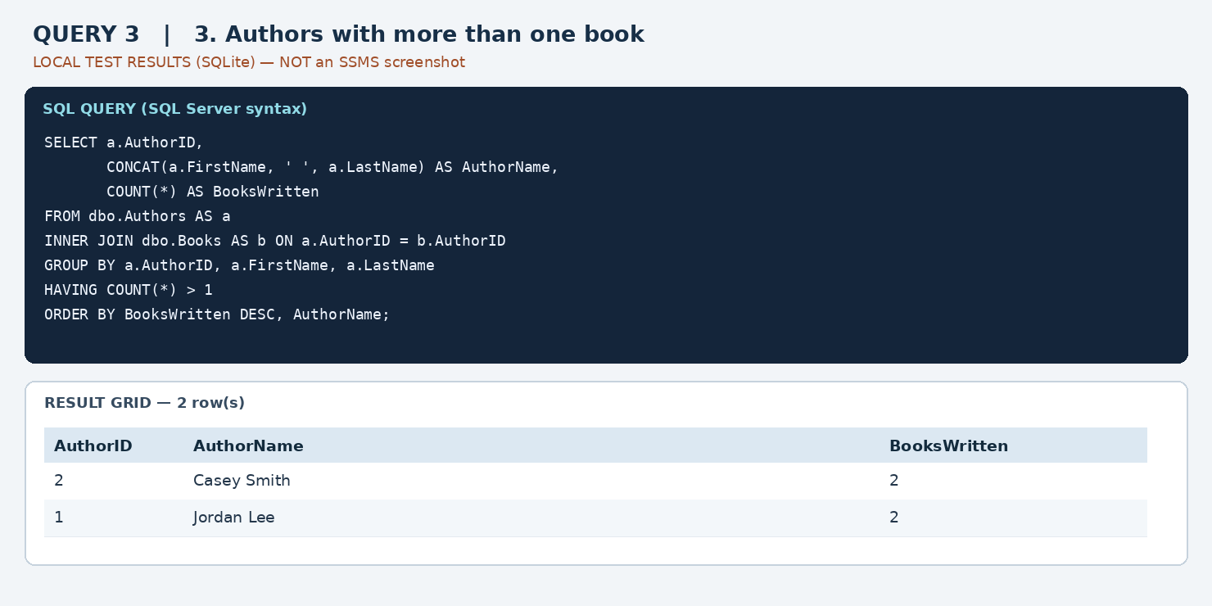

Query 4 | Increase prices by 10%
This statement updates all five prices by 10%. Run it only once after inserting the starting data.
UPDATE dbo.Books
SET Price = ROUND(Price * 1.10, 2);
SELECT BookID, Title, Price AS NewPrice
FROM dbo.Books
ORDER BY BookID;

Local verification panel (not an SSMS screenshot):
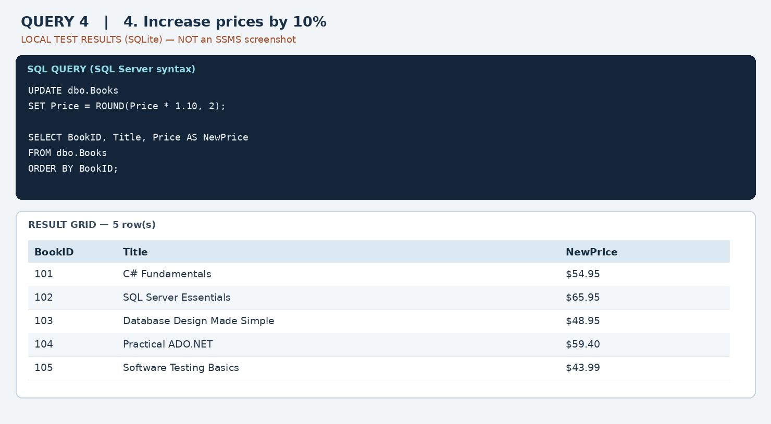

Query 5 | Delete one book and verify
This deletes BookID 105, then checks whether the record still exists. The expected verification is “Successfully removed.”
DELETE FROM dbo.Books WHERE BookID = 105;
SELECT CASE
WHEN EXISTS (SELECT 1 FROM dbo.Books WHERE BookID = 105)
THEN 'Still present'
ELSE 'Successfully removed'
END AS DeleteCheck;
SELECT * FROM dbo.Books WHERE BookID = 105;

Local verification panel (not an SSMS screenshot):
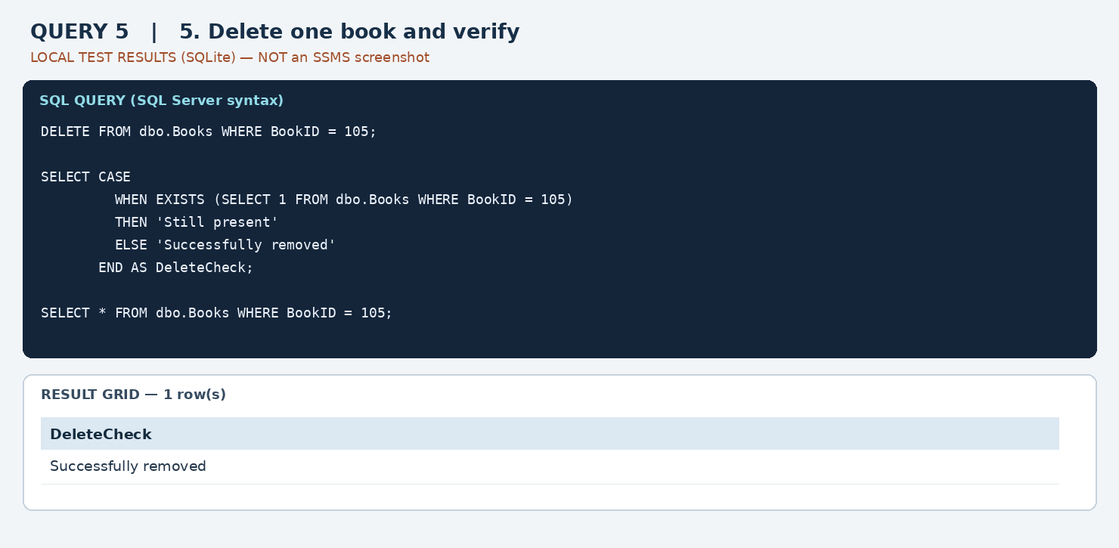

SSMS screenshot checklist
For each of the five queries, open SSMS or Azure Data Studio, execute the query, and take a screenshot including both the SQL text and the result grid. Replace the local verification panel with that screenshot before submission.

